NAME: Arundarasi Rajendran

PRN: 18070122081

BATCH: C4

**ABOUT UNIX**

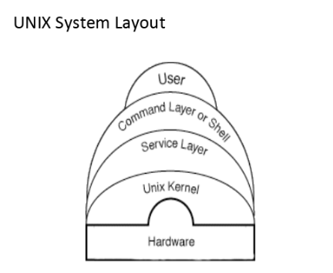

Unix is an operating system that was developed in 1960. It has been under development ever since 1960. It is a portable, multitasking, multi user, time-sharing operating system. They are widely used in PCs and mobile devices.

UNIX operating system has a graphical user interface that is very similar to Microsoft Windows. The types of UNIX share common similarities and these are Linux, MacOS X, and Sun solaris. The UNIX operating systems is made up of three parts: the kernel, shell, and the programs.

The kernel of UNIX is the central part of the operating system because it allocates time and memory to programs and handles the filestore and communications in response to system calls. To illustrate the interaction between the shell and the kernel, suppose a user types *rm myfile* that removes a file the shell searches in the filestore containing that program and removes it. Then it requests the kernel through system calls to execute the program *rm* on *myfile*. Once the process *rm myfile* has finished the shell returns the UNIX prompt to the user showing that it is waiting for further commands.

Shell is a command line interpreter (CLI). It interprets the commands the user inputs and arranges for them to be carried out. The commands are in fact programs and when they end the shell gives the user another prompt. The shell is an interface between the user and the kernel. When a user logs in, the login program checks the username and password then it begins another program called the shell. A user can customize his or her own shell and users can use different shells on the same machine.

The entire UNIX is either a file or a process. A process is an executing program referred by a process identifier and a file is a collection of data that are created by users using text editors, running compilers.

The directory structure in UNIX is hierarchical in which all the files are grouped together and it is similar to an inverted tree. Below is a diagram of the structure of how files are stored and traced.

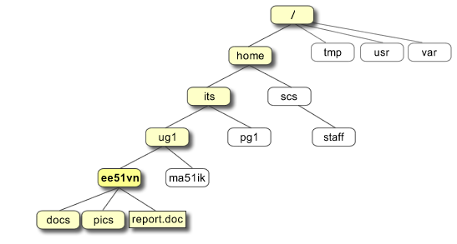

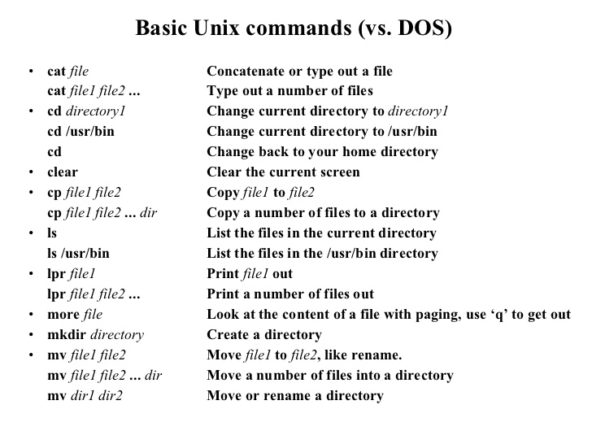

**ABOUT LINUX**

Linux is an operating system that is similar to unix operating system. It is basically a kernel and it is distributed under an open source license. It is one of the most popular and widely used kernels around the globe. It was developed by Linus Torvalds and others in 1991. Every version of Linux operating system manages hardware resources, launches, and handles applications, and provides some form of user interface.

The linux components include a bootloader, kernel, and package manager software. The kernel is the core of Linux operating system because it handles network access, scheduling processes or applications, manages basic peripheral devices and overseeing file system devices. There are modules to provide a command line interface, implement a graphical user interface, manage security, and offer video input or audio services. Package manager software adds, updates or removes software components under the Linux operating system. For example, package managers include dpkg, OpenPKG and more.

The main advantage of using this operating system is that programmers were able to use the Linux Kernel to design their own custom made operating systems. It also offers a free operating system. Since it is open-source anyone with programming knowledge can modify it.

